Big O Notation

What is Big O Notation?
Big O notation measures how an algorithm's / program logic execution time or memory usage grows as the input size (n) increases.

Instead of focusing on exact execution time, it focuses on the growth rate.

- Why Do We Need Big O?

Suppose you have two solutions:

# Solution 1
for i in range(n):
print(i)

# Solution 2
for i in range(n):
for j in range(n):
print(i, j)

Both solution will work, but:
- Solution 1 performs n operations → O(n)
- Solution 2 performs n × n operations → O(n²)
For small inputs, the difference is minor. But for large inputs, O(n²) becomes much slower.

Common Big O Complexities

Complexity | Name | Example
O(1) | Constant | Accessing array element
O(log n) | Logarithmic | Binary Search
O(n) | Linear | Single loop
O(n log n) | Linearithmic | Merge Sort
O(n²) | Quadratic | Nested loops
O(2ⁿ) | Exponential | Recursive Fibonacci
O(n!) | Factorial | Traveling Salesman (brute force)

Performance Ranking
Best → Worst
O(1)
O(log n)
O(n)
O(n log n)
O(n²)
O(2ⁿ)
O(n!)

O(1) – Constant Time
arr = [10,20,30,40]

print(arr[2])

No matter whether the array has 10 elements or 10 million elements, accessing an index takes the same time.
Complexity = O(1)

O(n) – Linear Time
for item in arr:
print(item)

Here in loop its going to all the elements in an array. If array size doubles, operations double.
Complexity = O(n)
Note:- For single for loop the time complexity will be always O(n)

O(n²) – Quadratic Time
for i in arr:
for j in arr:
print(i, j)

Here all the element in an array is read 2 times as we are using two for loop.
For:
- n = 10 → 100 operations
- n = 100 → 10,000 operations
- n = 1000 → 1,000,000 operations
Complexity = O(n²)
Note:- For double for loop on same array,the time complexity will be always O(n²)

O(log n) – Binary Search
Instead of checking every element, Binary Search repeatedly divides the search space into half.

1,2,3,4,5,6,7,8,9

n = 8 → 3 steps
n = 16 → 4 steps
n = 32 → 5 steps
n = 64 → 6 steps

Complexity = O(log n)

Practice Questions
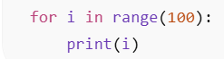 Big O = O(1)

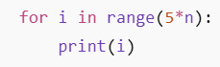 Big O = O(n)

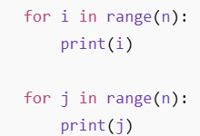 Big O = O(n)

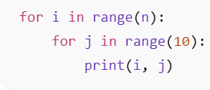 Big O = O(n)

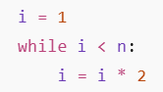 Big O = O(log n)

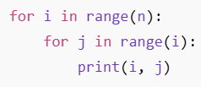 Big O = O(n²)

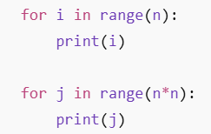 Big O = O(n²)

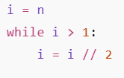 Big O = O(log n)

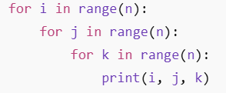 Big O = O(n3)

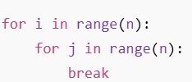 Big O = O(n)

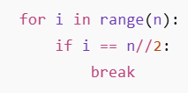 Big O = O(n)

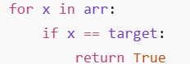 Big O = O(n)

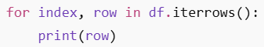 Big O = O(n)

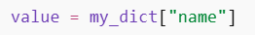 Big O = O(1)

